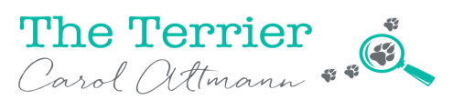
Application form
Indigenous mentorship in digital story telling/journalism
Full name: __________________________________________
Address: ____________________________________________
Contact details (phone/email): ______________________________
Date of birth: _____________________________________________
Education and prior work experience: ___________________________
___________________________________________________________
___________________________________________________________
Tell us why you would love to become a digital story teller (feel free to add pages):

Please return this form by no later than Friday 6 March 2020 to:
Carol Altmann ‘The Terrier’
altmanncarol@gmail.com

